### **Day 4 - Dynamic Frontend Components**

**[Hekto: Building the Future of Furniture Shopping]**

## **1. Introduction**

This document provides an overview of the **E-Commerce Web Application**, developed using **Next.js** and **Sanity CMS** for content management. The application enables users to interact with various components, including product listings, shopping carts, checkout processes, and more. The primary goal is to deliver a seamless and user-friendly e-commerce experience with dynamic routing and integration with a headless CMS.

### **Technologies Used**

* **Frontend**: React, Next.js
* **State Management**: React Context API
* **Database/Content Management**: Sanity CMS
* **Libraries/Tools**: Axios, React Toast Notifications, LocalStorage
* **Deployment**: Vercel (or specify another platform if applicable)

## **2. Project Overview**

The application delivers essential e-commerce functionalities, ensuring smooth and intuitive user interactions. Users can browse products, manage their shopping carts and wishlists, complete the checkout process, and provide feedback. Dynamic routing allows users to explore specific product pages effortlessly.

### **Core Features**

* **Product Listing**: Displays products fetched from the CMS in a responsive layout.
* **Product Detail Page**: Dynamic display of detailed product information.
* **Search Bar**: Allows users to search products by name or keyword.
* **Shopping Cart**: View, manage, and update cart items.
* **Wishlist**: Save favorite products for later use.
* **Checkout**: Provides a form for secure order processing.
* **Pagination**: Efficiently manages large product datasets.
* **Filter and Sorting**: Allows sorting products by price, category, etc.
* **Related Products**: Displays relevant items based on user interest.
* **Header and Footer**: Common UI components across pages.
* **Notifications**: Real-time updates on user actions (e.g., adding to the cart).
* **FAQ and Help Center**: Support for user inquiries and common questions.
* **Customer Feedback**: Collects and displays product reviews from users.
* **Loading Component**: Displays a spinner animation and loading message for better user experience.
* **Dynamic Routing**: Provides routes for shops and product pages for easy navigation.

## **3. Architecture Overview**

The architecture of the application follows a clean and modular structure with a clear separation of concerns, ensuring maintainability and scalability. Below is an overview of the architecture:

### **Application Flow**

1. **Frontend Layer**
   * Built using **React** and **Next.js** for efficient rendering and interactivity.
   * Incorporates **Tailwind CSS** for styling and responsive design.
2. **State Management**
   * Utilizes **React Context API** for managing global states such as cart, wishlist, and user preferences.
3. **Backend Layer**
   * **Sanity CMS** is used to manage product data dynamically.
   * RESTful APIs are integrated for fetching data.
4. **Routing**
   * **Dynamic Routes**: Handles shop and product pages based on parameters.
   * **Static Routes**: Includes FAQ, feedback, and other standard pages.
5. **Notifications**
   * User actions trigger toast notifications for real-time updates.
6. **Deployment**
   * Hosted on **Vercel** for fast, scalable deployment.

**[Frontend - Next.js]**

**├── Components (Header, Footer, Product Listing, Cart, etc.)**

**│**

**├── Pages (Dynamic Routing: /shop/[id], /product/[id])**

**│**

**├── Context API (Cart, Wishlist, Global States)**

**│**

**└── Tailwind CSS (Styling and Responsiveness)**

**│**

**[Sanity CMS - Backend]**

**│**

**└── Product Data Management and API Integration**

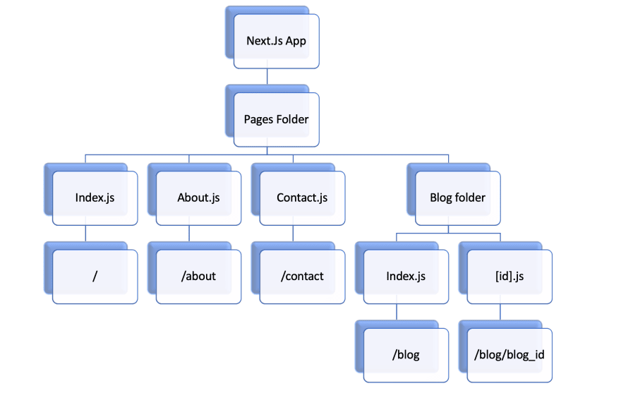

# Component Breakdown

Below is an overview of the major components of the application, detailing their purpose, implementation, challenges, and solutions.

## 1. **Product Listing Page**

### **Description**

This page displays products fetched from Sanity CMS in a responsive grid layout. It features product images, names, prices, and options to:

* Add products to the cart.
* Add to the wishlist.
* View product details.

The page supports dynamic loading with a "Load More" button to display additional products.

### **Implementation Challenges & Solutions**

1. **Data Fetching**
   * **Challenge**: Fetching product data from Sanity.
   * **Solution**: Used useEffect for data fetching on component mount and useState to store and display the data.
2. **Pagination**
   * **Challenge**: Dynamically loading more products.
   * **Solution**: Implemented a "Load More" button to increase the visible product count by 8 on each click.
3. **Responsive Layout**
   * **Challenge**: Ensuring the grid adjusts to various screen sizes.
   * **Solution**: Used Tailwind CSS grid classes for responsive design.
4. **Hover Effects**
   * **Challenge**: Displaying action icons (e.g., add to cart) only on hover.
   * **Solution**: Leveraged Tailwind's group-hover and transition classes for smooth interactivity.

## 2. **Product Detail Page**

### **Description**

This page displays detailed product information, including:

* Image, name, price, discount percentage.
* Description, stock availability, and category.
* Options to adjust quantity, add to cart, mark as a favorite, and share on social media.

### **Implementation Challenges & Solutions**

1. **Data Fetching**
   * **Challenge**: Ensuring data loads correctly for specific product IDs.
   * **Solution**: Used dynamic queries with Sanity and implemented error handling with try-catch.
2. **Stock Management**
   * **Challenge**: Preventing users from adding unavailable stock to the cart.
   * **Solution**: Disabled the "Add to Cart" button for out-of-stock items and displayed stock alerts.
3. **User Interaction**
   * **Challenge**: Managing cart updates and favorite toggles.
   * **Solution**: Used state management for real-time updates.
4. **Dynamic Description**
   * **Challenge**: Handling missing or lengthy descriptions.
   * **Solution**: Added conditional rendering for missing descriptions and truncation for lengthy ones.

## 3. **Search Bar Component**

### **Description**

The search bar enables users to find products quickly by typing keywords. Features include:

* Prominent placement in the header.
* Real-time query suggestions and autocomplete.
* Category filters for enhanced usability.

### **Challenges & Solutions**

1. **Performance**
   * **Challenge**: Optimize search algorithms.
   * **Solution**: Implemented indexing and caching for faster results.
2. **Autocomplete**
   * **Challenge**: Handle typos and partial matches.
   * **Solution**: Incorporated fuzzy matching.
3. **Design**
   * **Challenge**: Ensure a responsive, intuitive interface.
   * **Solution**: Used Tailwind CSS for consistent design across devices.

## 4. **Cart Page**

### **Description**

The cart allows users to:

* Add, remove, and update product quantities.
* Apply promo codes and select shipping methods.

### **Implementation**

* Used React Context API for global cart state management.
* Functions like addToCart, removeFromCart, and updateQuantity manage interactions.

### **Challenges & Solutions**

1. **State Management**
   * **Challenge**: Managing cart state across multiple components.
   * **Solution**: Used Context API for centralized state.
2. **Dynamic Updates**
   * **Challenge**: Updating item quantities efficiently.
   * **Solution**: Local state tracked changes before global updates.
3. **Promo Codes**
   * **Challenge**: Handling dynamic discount applications.
   * **Solution**: Applied conditional logic for promo code validation.

## 5. **Wishlist Page**

### **Description**

The wishlist allows users to:

* Save favorite products.
* View a list of saved items.
* Remove items when needed.

### **Implementation**

* Used React Context API for global wishlist state.
* Functions manage adding/removing items.

### **Challenges & Solutions**

1. **State Synchronization**
   * **Challenge**: Keeping the wishlist state updated across components.
   * **Solution**: Used centralized state with React Context.
2. **UI Updates**
   * **Challenge**: Ensuring real-time changes.
   * **Solution**: React’s useState dynamically updated the UI.

## 6. **Pagination Component**

### **Description**

Enables navigation between pages with features like:

* Dynamic page numbers.
* Previous/Next buttons.
* Ellipses for skipped pages.

### **Challenges & Solutions**

1. **Edge Cases**
   * **Challenge**: Handling edge cases with few pages.
   * **Solution**: Adjusted logic for proper rendering.
2. **Ellipses Rendering**
   * **Challenge**: Displaying skipped pages correctly.
   * **Solution**: Conditionally rendered ellipses for smooth transitions.

## 7. **Filter and Sorting Component**

### **Description**

Allows users to:

* Filter by the number of products per page.
* Sort by criteria like "Price: Low to High".
* Toggle between grid and list views.

### **Challenges & Solutions**

1. **Dynamic Results**
   * **Challenge**: Managing different filters dynamically.
   * **Solution**: Structured components for easy state management.
2. **Responsive Design**
   * **Challenge**: Ensuring usability on all screen sizes.
   * **Solution**: Used Tailwind CSS for layout adjustments.

## 8. **Dynamic Routing**

### **Description**

Implements dynamic routes for:

* **Shop Page** (/shop/[id])  
  Displays products for a specific shop.
* **Product Page** (/product/[id])  
  Displays detailed information about a product.

### **Implementation**

* Dynamic routes in /pages/shop/[id] and /pages/product/[id].
* Fetched product details using id parameters.

## **5. Data Sanity and Database Management**

Using **Sanity CMS** as the backend ensures efficient content management, but maintaining data accuracy and reliability is critical. To achieve this, regular checks and validation procedures are in place to guarantee that the fetched data meets the expected standards.

### **Sanity Check Procedures**

1. **Data Validation**
   * Ensures that all required fields (e.g., product name, price, image, description) are present in the fetched data.
2. **Data Consistency**
   * Verifies that product data matches expected formats, with no missing fields or incorrect data types.
   * Example: Ensures price is a number and image URLs are valid.
3. **API Health Checks**
   * Periodically tests the CMS API to ensure it is responsive and returns valid, up-to-date data.

These measures enhance data reliability and ensure a seamless user experience.

## **6. Conclusion**

The **E-Commerce Web Application** is a robust and user-friendly solution for building online stores. By leveraging **Next.js** and **React**, the application ensures dynamic and responsive interactions while utilizing **Sanity CMS** for flexible content management.

### **Key Achievements**

* Successfully implemented dynamic routing using **Next.js**, enabling easy navigation to product and shop pages.
* Used **React Context API** for managing global state, ensuring seamless navigation and functionality across components.
* Integrated **localStorage** to persist data such as cart and wishlist items, providing a better user experience.

### **Future Enhancements**

* **Integration of a Live Payment Gateway**: Enabling secure and real-time payment processing.
* **Advanced Filtering and Sorting**: Improving product search capabilities with more complex filters and sort options.
* **User Authentication and Authorization**: Adding login and role-based access control for enhanced security and personalized user experiences.

This documentation outlines the core components of the application, presenting a clear overview of its architecture, features, and the challenges addressed during development. The project is designed with scalability, ease of use, and flexibility in mind, allowing for seamless future enhancements.

### **Day 4 Checklist**

* Implemented dynamic routing for shop and product pages.
* Added a loading component styled with Tailwind CSS.
* Performed data validation and consistency checks for Sanity CMS integration.
* Integrated React Context API for global state management.
* Persisted cart and wishlist data using localStorage.

**E-Commerce Web Application Overview**

This document outlines an **e-commerce web application** developed using **Next.js**, **React**, and **Sanity CMS**. The application integrates key functionalities for a seamless online shopping experience.

### **Core Features:**

* **Dynamic Routing**: Enables navigation to specific product pages.
* **Product Listings & Details**: Displays products fetched from Sanity CMS.
* **Search Functionality**: Allows users to quickly find products.
* **Shopping Cart & Wishlist**: Users can manage items and save favorites.
* **Checkout Process**: Enables order processing.
* **Pagination**: Efficiently handles large product datasets.
* **Filtering & Sorting**: Users can refine product searches.
* **Related Products**: Displays similar items to enhance shopping experience.
* **Header & Footer**: Provides navigation, language, and currency options.
* **Notifications**: Real-time alerts for actions like adding to the cart.
* **FAQ & Help Center**: Offers user support and answers frequently asked questions.
* **Customer Feedback**: Allows users to submit product reviews.
* **Loading Component**: A reusable spinner component for visual feedback during data fetching.

### **Technologies Used:**

* **Frontend**: React, Next.js
* **State Management**: React Context API
* **Content Management**: Sanity CMS
* **Local Storage**: For persisting cart and wishlist data